PROJECT OUTPUTS

**1.Create Main Folder:**

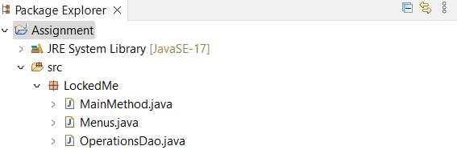

**2.Welcome Screen:**

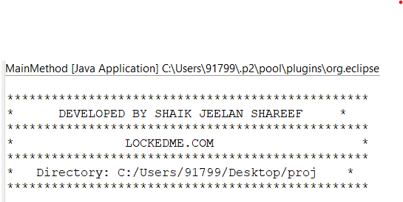

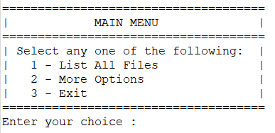

**3.Display Main Menu:**

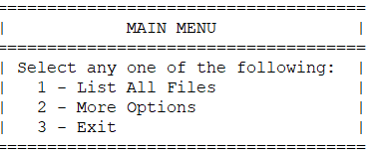

**4. Flow Chart:**

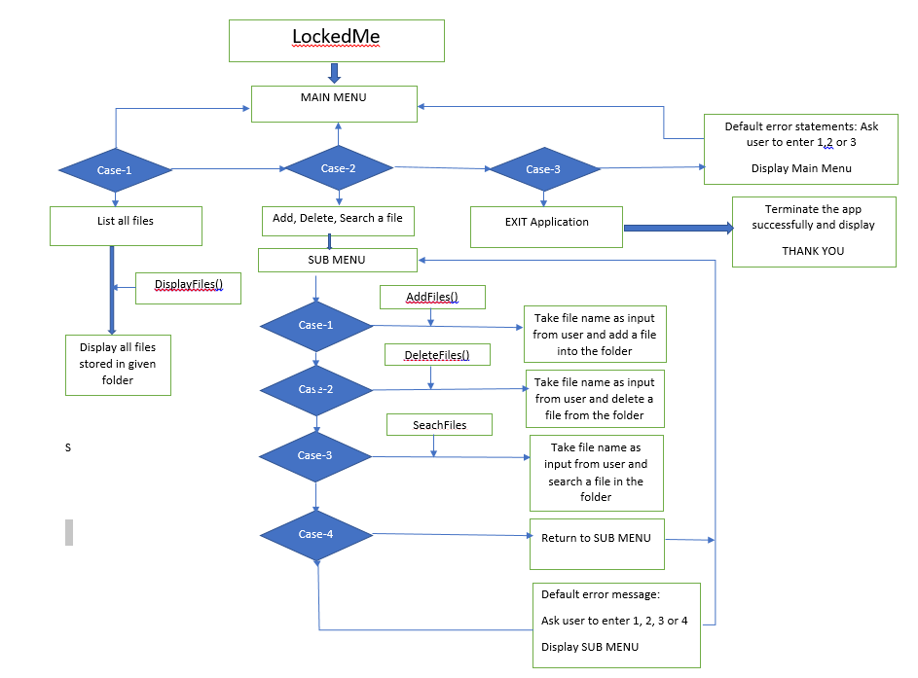

**5.List of all files:**

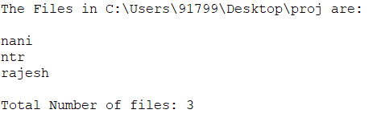

**6.Add file:**

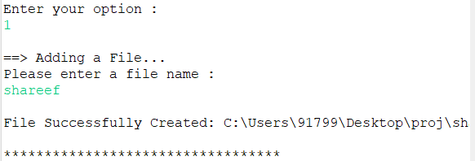

**7.Deleting file:**

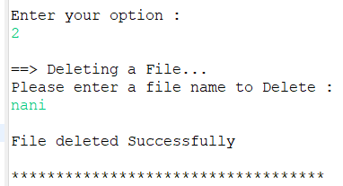

**8.Searching file:**

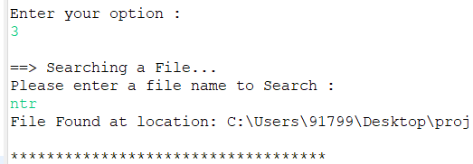

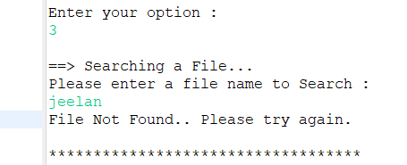

**9.Program to exit:**

